How to Add ShepOWL onto your Sakai sites:

- Log onto Sakai and click on My Workspace (top left hand side)
- In the tool navigation menu (left hand side), click on Membership
- Click on Joinable Sites on the top
- Look for 201630-ENGL-999:01 and click on it
- If the site doesn’t show up in your list of courses, click on My Sites (top right hand corner), click on preferences and make sure the site is not hidden

How to access the essay you’ve been assigned:
- Go to our ShepOWL Sakai site: 201630-ENGL-999:01
- Click on Assignments and click on View Submissions for the assignment date you were assigned
- Look for the student you were assigned and click on his/her turnitin report icon

How to leave feedback on an essay:

- Enable Grading mode:
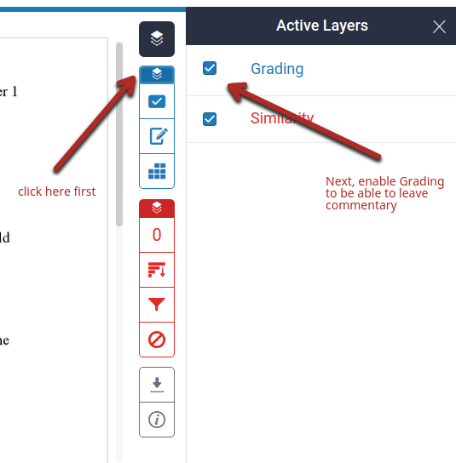

2. Click on the essay to leave a comment
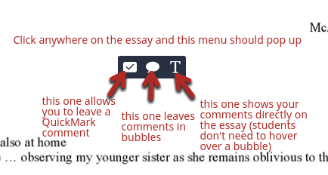

3. When you leave commentary, focus on higher order concerns: does this essay do what the prompt asks students to do? Does it have an argument? Is it organized in a logical fashion? Etc.
Students will always think that grammar is a main concern/issue, but don’t prioritize it until you’ve analyzed the larger issues.

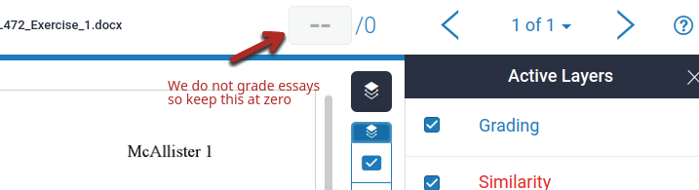
4. Leave a zero for the grade

5. In the Instructor Summary Comments, please include the following link so that students know how to see your commentary. Please highlight or make the font big and a different color so that it catches the student’s attention: https://docs.google.com/document/d/17Kv7BAl4kti01teeuWkAJ_zUyrIBMmYGeL8H7RI9CDc/edit#heading=h.4kodyxrlyjf

It should look like this:
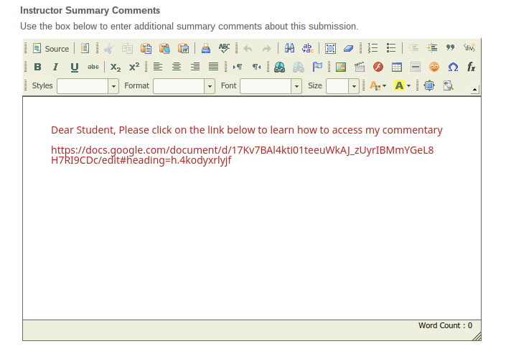

Close your turnitin tab and go back to Sakai. You can enter a grade of zero and on the bottom click on “Save and Release to Student” so that the student can access your feedback
