Tractor Supply Company DC Operations Summer Internship Opportunity (On-Site)
Hagerstown, MD

Location: Hagerstown, MD
Who: Must be enrolled in or recently graduated from an accredited university; rising seniors preferred
Website: Hagerstown DC Internship Application
Summer hourly rate: $20-$25/hour (depending on the candidate’s major and year in school)
Internship dates: May 18 - July 31, 2026 (11 weeks)
Relocation stipend: $2,500
Internship Description: (DC Operations Intern)
This is an 11-week rotational internship at Tractor Supply’s Hagerstown, MD Distribution Center, designed to provide hands-on exposure to core operational functions. Interns will rotate through key departments including Receiving, Letdown, Inventory Control, Order Fill, Shipping, and Production Planning to gain a comprehensive understanding of how these areas work together to move products efficiently to stores and customers.

Throughout the program, you’ll take ownership of impactful projects focused on safety, productivity, quality, and continuous improvement. Using data and observations, you’ll develop and present solutions that make a real difference.

The internship includes structured mentorship and coaching from leaders in Operations and Human Resources, as well as opportunities for leadership development. At the conclusion of the program, interns will present their findings and project outcomes to Distribution Center leadership.

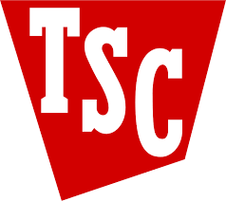



Company Overview & History
Scan to Apply!

